Lab 1.2 – Using Wireshark to Observe the TCP 3-Way Handshake View Network Traffic

Student Name: Mohamad Mostafa (ID: 30930)

Part 1: Prepare Wireshark to Capture Packets

Step 1: Retrieve your PC Interface Addresses

IPv4 Address: 192.168.1.116
MAC Address: 9C-AD-97-30-57-CF
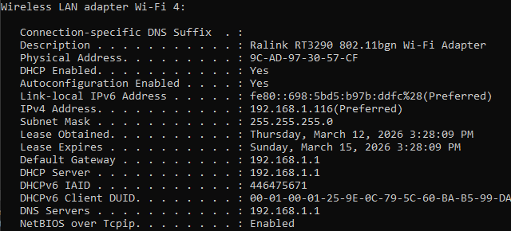

Step 2: Start Wireshark and Begin Capturing Data

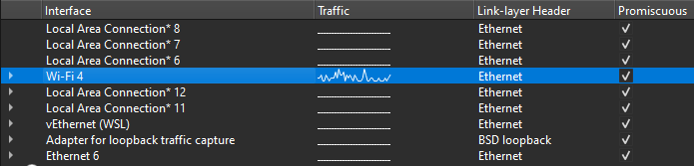
Part 2: Capture, Locate and Examine Packets

Step 1: Capture the data
Opened https//google.com from the browser and stopped Capturing Data
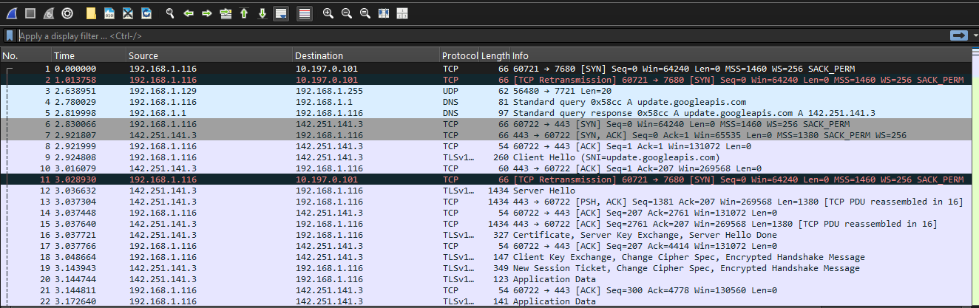

Step 2: Locate appropriate packets for the web session.
Before establishing connection: ARP, DNS, TCP 3-Way Handshake
(ARP : Resolves MAC address before IP communication)
The PC already had an ARP entry for the default gateway

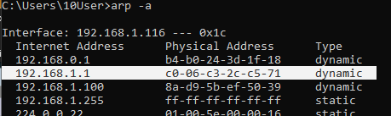

which means that it started with the DNS query to resolve www.google.com

(DNS: Resolves domain name (www.google.com) to IP address)

The PC must have the IP address of the DNS server, which is attempting to resolve the domain
name www.google.com to the IP address of the web server. before it
can send the first packet to the web server.
the IP address of the DNS server that the computer queried: 192.168.1.1
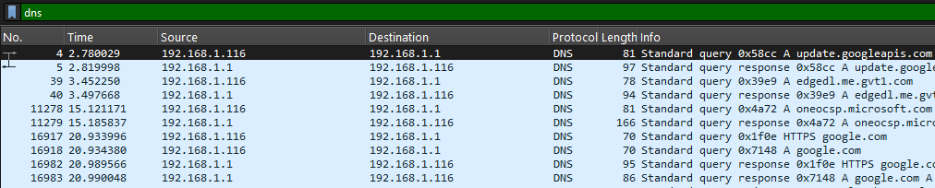
The response from the DNS server. It contains the IP address of www.google.com.
142.250.203.206
with nslookup command.
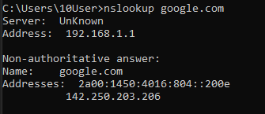

TCP three-way handshake
For establishing reliable connection

[SYN]
[SYN, ACK]
[ACK]
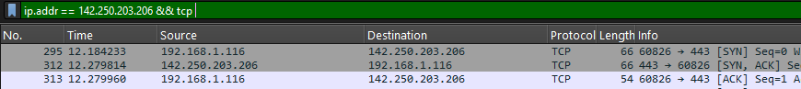

Step 3: Examine the information within packets including IP addresses, TCP port numbers, and TCP control flags

- [SYN]
Client requests connection, sends initial sequence number
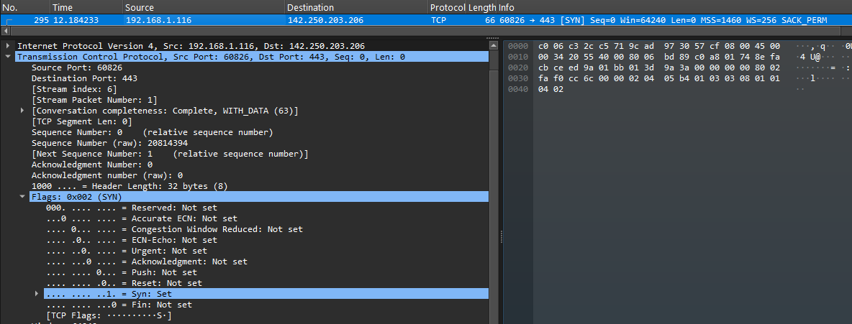

TCP source port number: 60826, it’s a dynamic port assigned by the OS for client-side connections

TCP destination port number: 443, it’s a static (well-known) port used by HTTPS

Flag “Syn” is set with relative number 1

.... .... ...1 = Syn: Set
[TCP Flags: ··········S]

- [SYN,ACK]
Server acknowledges client request, sends its own sequence number
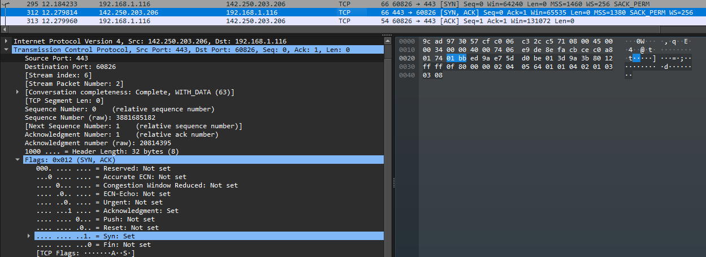

TCP source port number: 443

TCP destination port number: 60826

Flag “Syn” and “Acknowledgment” are set with relative number 1

.... ...1 .... = Acknowledgment: Set
.... .... ...1 = Syn: Set
[TCP Flags: ·······A···S]

- [ACK]
Client acknowledges server response
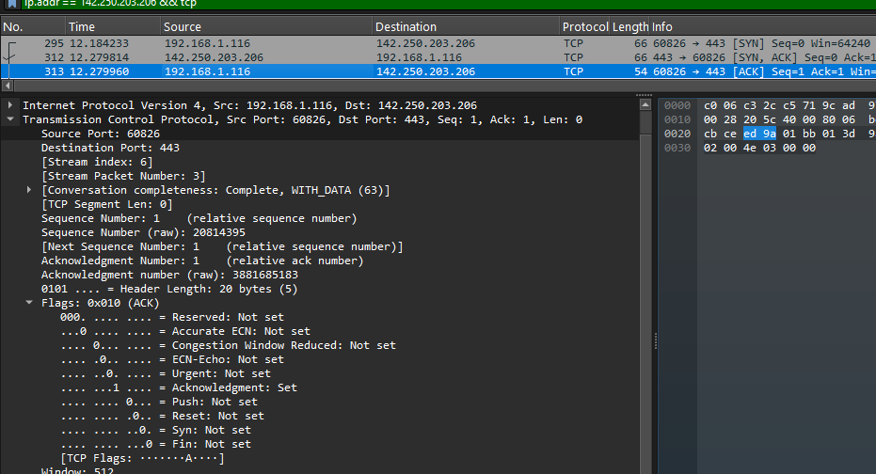

Source Port: 60826
Destination Port: 443
(Same source and destination as the second segment)
.... ...1 .... = Acknowledgment: Set
[TCP Flags: ·······A····]

The TCP connection is established and communication between the source computer and the web server can begin.

TCP Graph Statistics (Packets/seconds)

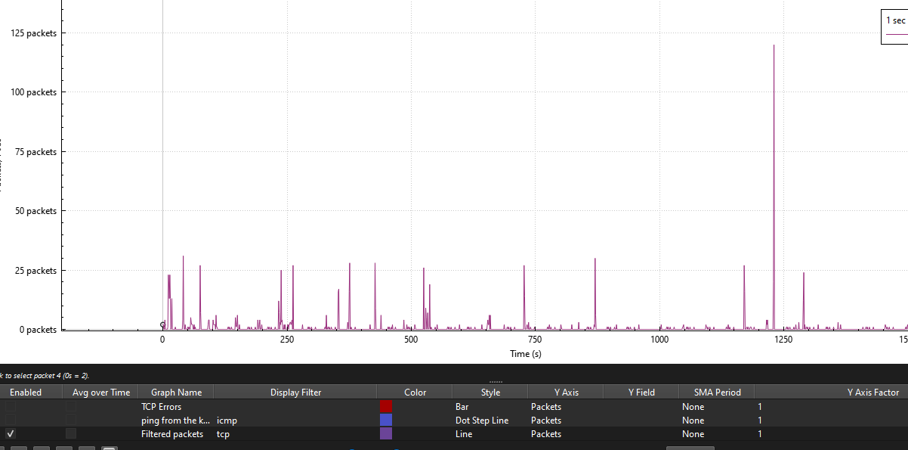

three useful Wireshark filters for network administrators

ip.addr == 192.168.1.1
this filter would be useful to isolate all traffic to or from the default gateway

!(arp or dns or tcp.port==443)
Shows everything except ARP, DNS, and HTTPS traffic. Helpful for filtering out "noise" to see other types of traffic.

tcp.flags.syn == 1
Filters for TCP SYN packets. Helpful for identifying new connection attempts, which can be useful for detecting port scans or monitoring how many connections are being initiated.

other ways Wireshark could be used in a production network
Network Troubleshooting: When users report that an application is slow or a website is inaccessible, a network administrator can use Wireshark to capture traffic and analyze the TCP handshake, look for TCP retransmissions (which indicate packet loss), or verify that requests are reaching the server and replies are coming back.

Security Analysis: Wireshark can be used to inspect traffic for signs of malicious activity, such as unusual outbound connections (which might indicate malware), port scans, or clear-text transmission of sensitive data (like usernames and passwords in protocols like FTP or Telnet).

Application and Protocol Analysis: Developers and administrators can use Wireshark to see exactly how a custom or proprietary application communicates over the network, helping to identify inefficiencies or bugs in the application's network code.

Lab Completion Checklist
☒ Retrieved PC IP address and MAC address using ipconfig /all
☒ Started Wireshark and selected the correct network interface
☒ Successfully captured packets while visiting www.google.com
☒ Located DNS query and response packets
☒ Identified DNS server IP address and Google web server IP address
☒ Applied TCP filter to isolate TCP traffic
☒ Located and examined the first packet (SYN) of the three-way handshake
☒ Identified source port, destination port, and SYN flag in Packet 1
☒ Located and examined the second packet (SYN-ACK) of the three-way handshake
☒ Identified source port, destination port, SYN flag, and ACK flag in Packet 2
☒ Located and examined the third packet (ACK) of the three-way handshake
☒ Identified ACK flag in Packet 3
☒ Verified TCP connection was successfully established
☒ Listed three useful Wireshark filters for network administrators
☒ Described other ways Wireshark could be used in a production network

THANK YOU.
Mohamad Mostafa (ID: 30930)

